
First Serbian (26th YU) Congress on Theoretical and Applied Mechanics
Kopaonik, Serbia, April 10-13, 2007

Full paper title (Times New Roman, 12 pt., bold)

First A. Author¹, Second B. Author², Third C. Author² (authors, 11 pt., bold)

¹ Institute of Mechanics (Times New Roman, 11pt.)
Ruhr-Universitat Bochum, Universitatsstr. 150, D-44801 Bochum, Germany
e-mail: first@first.com
² Faculty of Mechanical Engineering,
The University of Belgrade, Kraljice Marije 16, 11120 Belgrade 35
e-mail: second@second.com , third@third.com

Abstract:

Format of paper should be Word document. The paper has to be written in English using single spacing and Times-Roman font with 10 pt size.

Key words: word, word…(Times New Roman, 10pt.)

1. Introduction (section title, 11 pt, bold)

(Times New Roman, 11pt.) The purpose of the Congress is to bring together the scientific communities of Theoretical and Applied Mechanics in an effort to facilitate the exchange of ideas in topics of mutual interests and to serve as a platform for establishing links between research groups with complementary activities. The community of Theoretical and Applied Mechanics will benefit from this interaction, acquainting them with advanced methods which can highly assist in tackling complex mechanical problems…
The Congress will take place on the most beautiful mountain in the Southeastern Europe, Kopaonik.

2. Instructions…

(Times New Roman, 11pt.) Full paper (number of pages, with figures and tables within the text, has to be: 6). Literature or references are cited in the text by number in angular parenthesis, e.g. [1].
Deadline for presenting one page abstract is 15th November 2006. Acceptance of the paper:
30th November 2006. Deadline for submitting the full paper is 20th February 2007.

2.1 Instructions… (subsection title, 11 pt, italic)

(Times New Roman, 11pt.) Equations are to be prepared with Word’s Equation Editor or by MathType. Parameters for equation typing are the size 11 pt TNR; subscripts and superscripts 9 pt, sub-subscripts are 7 pt. Numbers, parenthesis and capital Greek symbols are not italic. All latin type variables A, B, X, Y, a, b, x, y as well as small Greek symbols are italic. For example: Sanford [13] generalizes the previous solution by considering a complex function
$η\left(z\right)=z⋅φ^{''}\left(z\right)+ψ^{'}\left(z\right)$, (1)
Graphs/Illustrations/Tables should be placed on the appropriate page, with the corresponding consecutively number and explanations under them (10 pt). The Figure 1 shows…
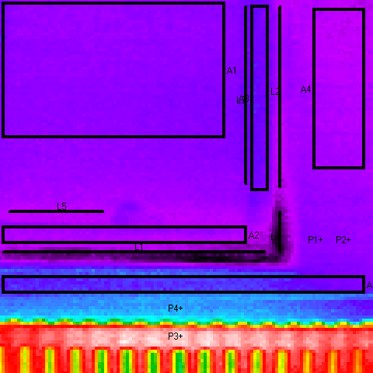
Fig. 1. Picture…

Figures and tables are centred … The text in Tables is TNR 10 pt, and is centred in table columns. See example below. It is shown in Table 1 that…

Results | Case 1 | Case 1 | Case 1 | Case 1
R1 | 3 | 1.2 | 4 | 5.9
R2 | 2.3 | 2.3 | 8 | 7.9

Table 1. Example

Please keep yourself to this template in preparing your paper, since it reduces the work of the editors, but some deviations from proposed form are acceptable…
Looking forward to meet you on the CONGRESS 2007. More information will be available at www.ssm.org.yu/congress2007 ...

3. Conclusions

(Times New Roman, 11pt.) Paper should be sent as attached file on the following e-mail address ssm.congress2007@sf.bg.ac.yu. The paper will be available both in paper (proceedings) and in digital form (CD)… Please, also give these information to other participants you know. Thanks for your contribution. The Organizing Committee.

References

- Lancaster P., Free vibrations of lightly damped systems by perturbation methods, Quarterly Journal of Mechanics and Applied Mathematics, Vol. 13, 138-155, 1960.
- Brandon, J.,A., Strategies for Structural Dynamic Modification, John Wiley & Sons INC, New York, 1990.

