10th International Congress of Serbian Society of Mechanics
Niš, Serbia, June 18-20, 2025
Isaac Elishakoff, Ph.D.
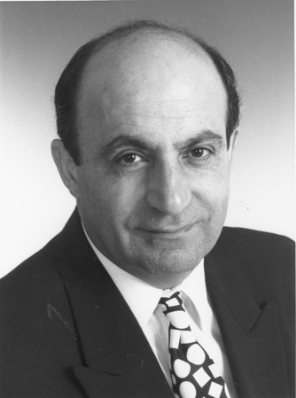
Hosted by the Serbian Society of Mechanics at the Faculty of Mechanical Engineering and the Faculty of Civil Engineering and Architecture, University of Niš
Short Professioal details and affiliation:
Isaac Elishakoff is a Distinguished Research Professor at Florida Atlantic University, USA, with 54 years of experience in theoretical and applied mechanics, specializing in probabilistic and deterministic mechanics,, composite materials, nanotechnology, stability, vibrations, and functionally graded structures. Isaac Elishakoff holds a Ph.D. degree from Moscow Power Engineering Institute and State Research University, and is the author of over 620 scientific papers and 34 published and edited books.

Plenary lecture
Resolution of the Twentieth Century Conundrum in Elastic Stability
Abstract: This lecture deals with the buckling of some structural elements in mechanical, aerospace, ocean, and marine engineering. For beams and plates, the theoretical and experimental values of buckling loads are in close vicinity. However, for stability of thin shells, the experimental predictions do not conform with the theory, due to presence of small geometric imperfections that are deviations from the ideal shape. This fact of discrepancy has been characterized to in the literature as ‘embarrassing’, ‘paradoxical,’ and ‘perplexing.’
Indeed, the popular adage, “In theory there is no difference between theory and practice. In practice there is”, very much applies to thin shells whose experimental buckling loads may constitute a small fraction of the theoretical prediction based on classical linear theory. Therefore, in practice, engineers use knockdown factors that are not theoretically substantiated.
This lecture presents a probabilistic approach that tames this prima-donna-like and capricious behaviour of structures that has been dubbed as ‘imperfection sensitive’ — thus resolving the conundrum that has occupied the best minds of elastic stability throughout the twentieth century, including Theodore von Kármán of RWTH Aachen University and Caltech, Warner Koiter of TU Delft, Bernard Budiansky of Harvard, Vladimir Bolotin of Russian Academy of Sciences, and others.

