**10th International Congress of Serbian Society of Mechanics**

**Niš, Serbia, June 18-20, 2025**

**Bernhard Semlitsch, Ph.D.**

**Hosted by the Serbian Society of Mechanics at the Faculty of Mechanical Engineering and the Faculty of Civil Engineering and Architecture, University of Niš**

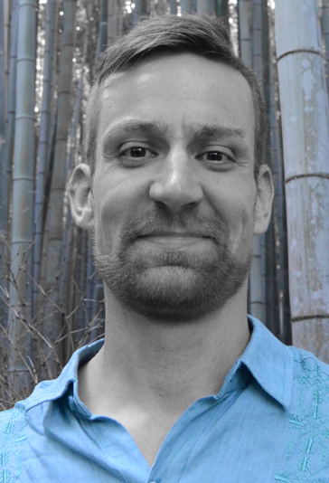

**Short Professioal details and affiliation:**

**Bernhard Semlitsch** graduated from **TU Wien** in the year 2010. He then continued his academic career at the **KTH Royal Institute of Technology** in Stockholm, where he received his **doctorate** in 2015 with his dissertation on "Large Eddy Simulation of Turbulent Compressible Jets." He then expanded his scientific expertise for several years as a postdoctoral researcher on thermoacoustic instabilities at the **University of Cambridge** before returning to TU Wien in 2020. Bernhard became an **Associate Professor** at **TU Wien** in 2024 and is an expert in the numerical simulation of coupling and resonance phenomena in turbomachinery.

**Plenary lecture  
*Modelling hot gas migration over gas turbine stages***

**Abstract:** Using lean-burn combustion technology, NOx emissions generated in the combustion process can be reduced. Because this lean-burn combustion process in aeronautic gas turbine engines is highly unsteady, vast amounts of cooling flows are needed to protect the combustor and turbine structure. Hot streaks can be generated and ingested during particular combustor operating conditions into the turbine. These hot streaks challenge the cooling strategies of the guide vanes. Thus, numerical simulations would be needed to guide the design of the cooling flows.

The lecture provides the physical background to understand the driving forces governing the migration path of hot and cold exhaust gasses. An approach for predicting their propagation through turbine stages will be presented, which is based on a force balance on streamlines. Furthermore, the numerical tools employed for validation will be given, and the implications for entropy noise generation will be discussed.